# CS 255 System Design Document

## UML Diagrams

### UML Use Case Diagrams

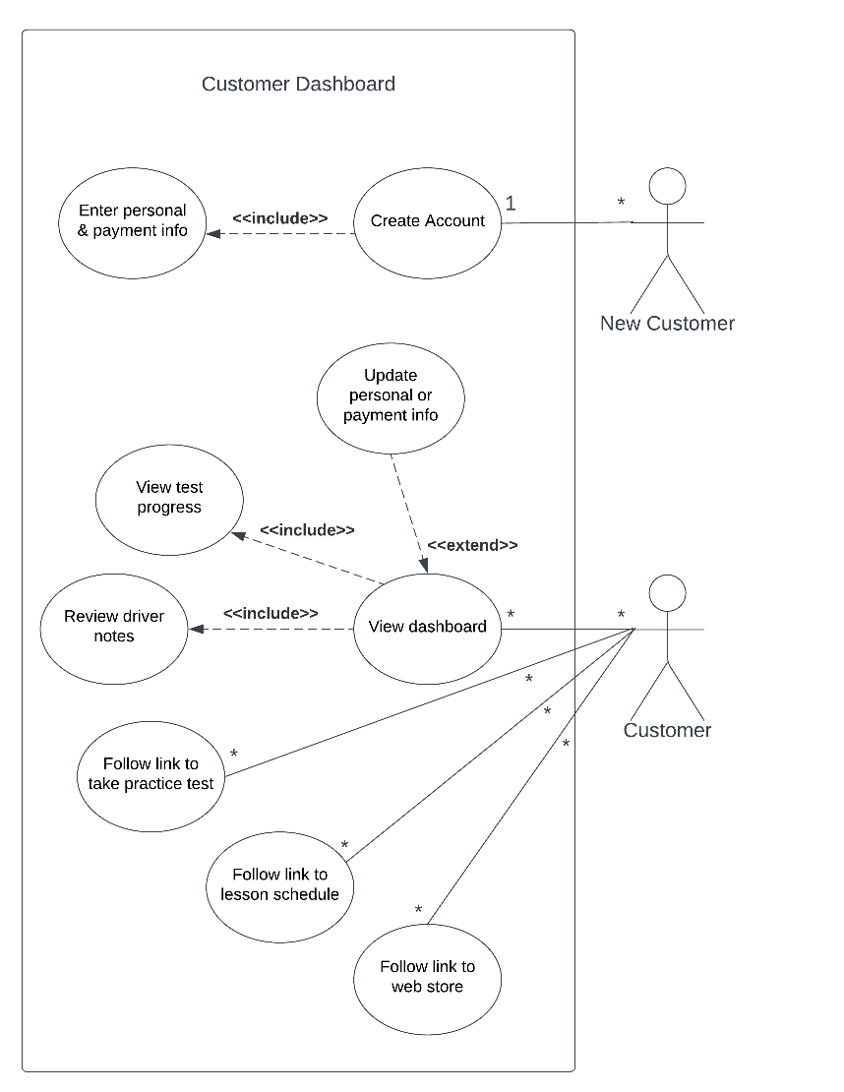

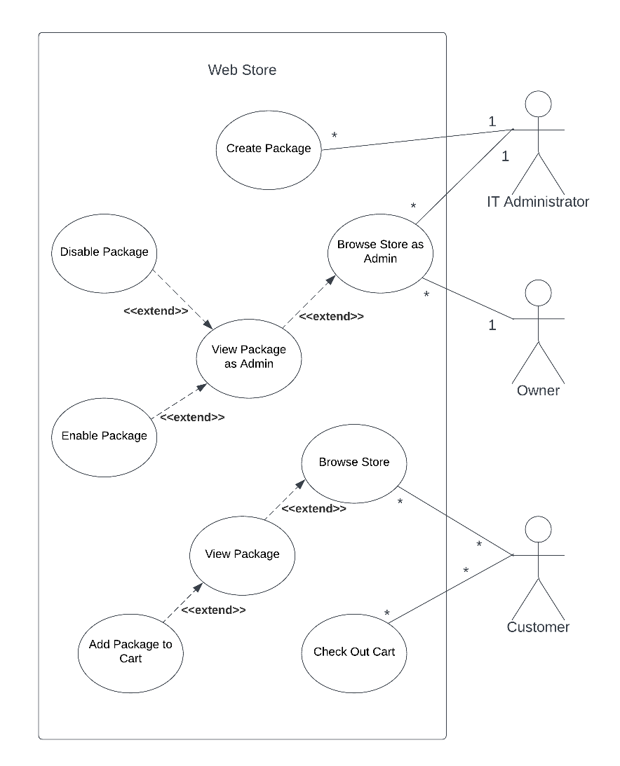

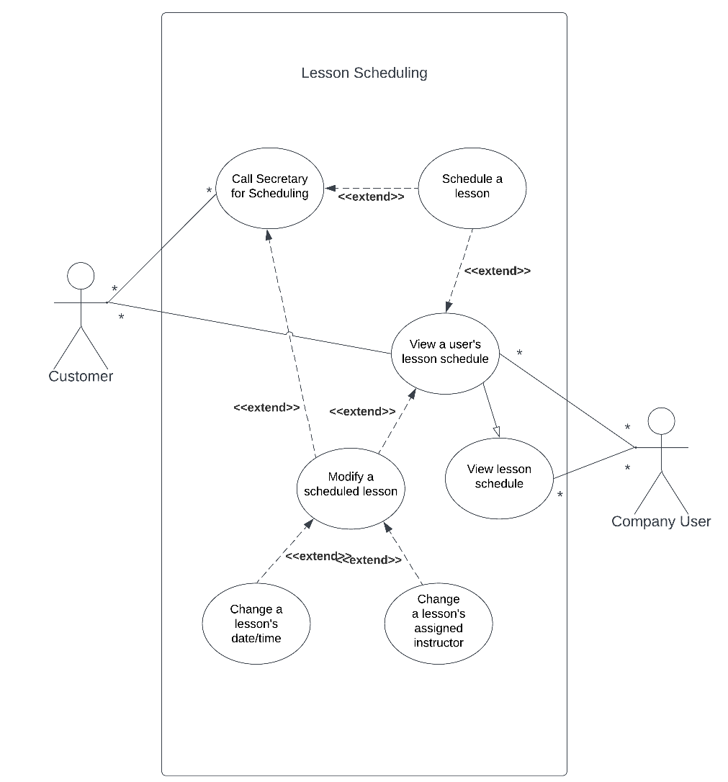

### UML Activity Diagrams

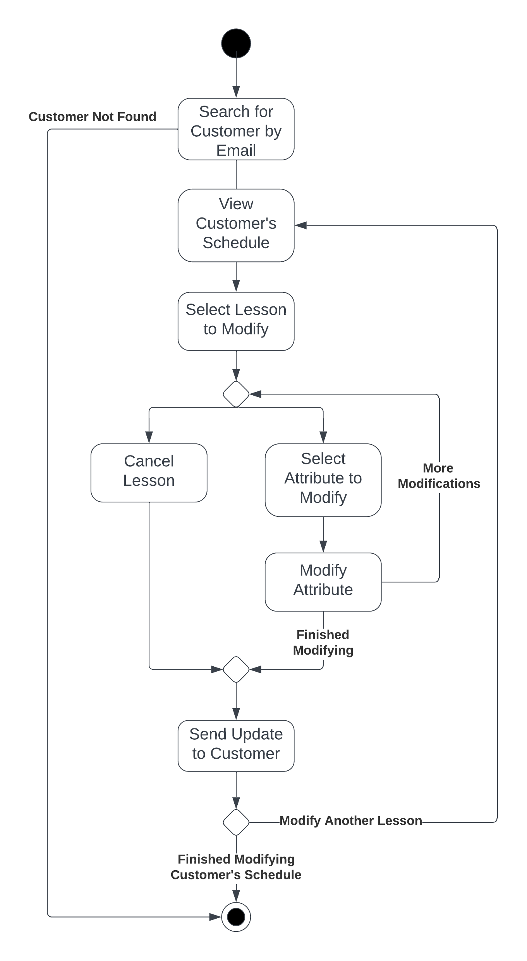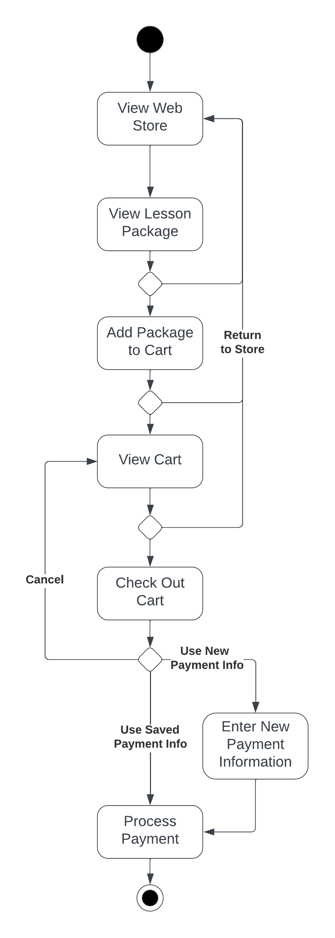

### UML Sequence Diagram

### UML Class Diagram

## Technical Requirements

**Hardware requirements:**

* The IT Administrator needs an internet-enabled desktop/laptop to access the cloud platform.
* All other users, including the Owner, other employees, and customers, need internet-enabled devices to access the system.
* DriverPass must have an internet connection in their office.
* Server hardware will be handled by the cloud platform service.

**Software requirements:**

* The server application will be deployed from a secure, up-to-date serverless platform.
* A web browser is necessary on any device accessing the system.
* The website’s UI must be designed to accommodate keyboard-and-mouse interfaces on desktop or laptop computers, as well as touch screen interfaces on mobile devices.
* The IT Administrator needs the ability to access the cloud platform and make changes/fix as required. This includes a browser but may also include an IDE and software tools; we will coordinate regarding specifics going forward.

**Infrastructure requirements:**

* The system must integrate a well-established, reputable third-party card processor with the web store to take payments.
* DriverPass must organize and operate out of their office (or an equivalent remote work setup).
* The Secretary must have a phone set up to take calls from customers.
* DriverPass must have cars for their instructors to use in.